Step 1: Before running your Honor/Merit Roll reports, you must refresh your GPA Set. Part of the GPA recalculation is the processing of the Honor/Merit rolls. You must also have Honor Rolls created – to verify this go to the Appendix A (Page 6) at the end of this document.
Go to: Home » Management » School Administration » Course History Administration » GPA Sets
- To Refresh the GPA Set, click the button below for the correct GPA you’d like to calculate for the Honor Roll.

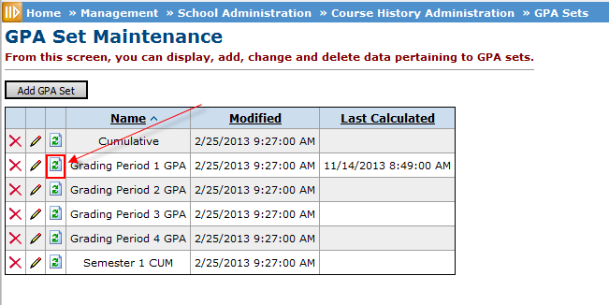

The screen above may have different GPAs based on your building.

Step 2: Once you click the refresh button, the job will be sent to the MGMT screen Press Mgmt link.
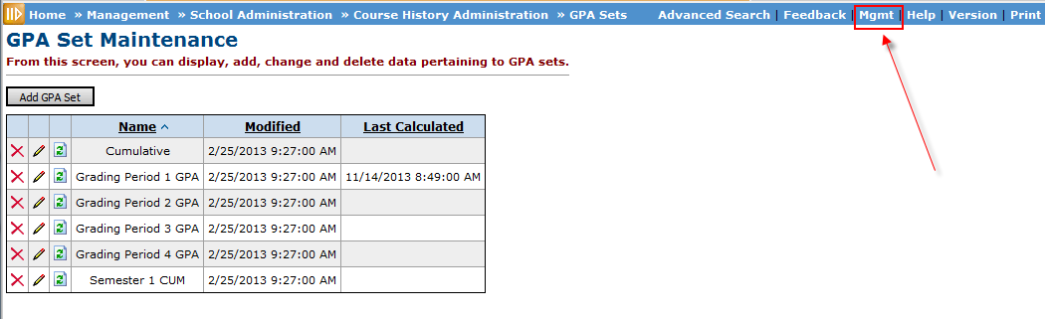

- Below you can see the job is active, which means it is not yet completed. To refresh the status of a job, you will need to refresh the display by clicking the Refresh Display button. Some jobs take longer than others, so you may have to keep refreshing or wait a few minutes between refreshings.
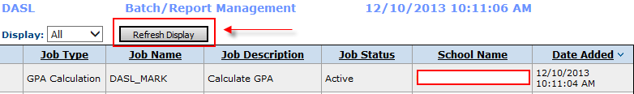

- Once GPA is has been recalculated and the Honor Roll calculated, the status will change to Complete.
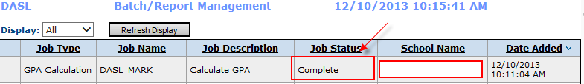

Step 3: We are now ready to run the R303 –Honor Roll Report.
Go to: Home » SIS » Marks » Marks Reports » Honor Roll (R303)
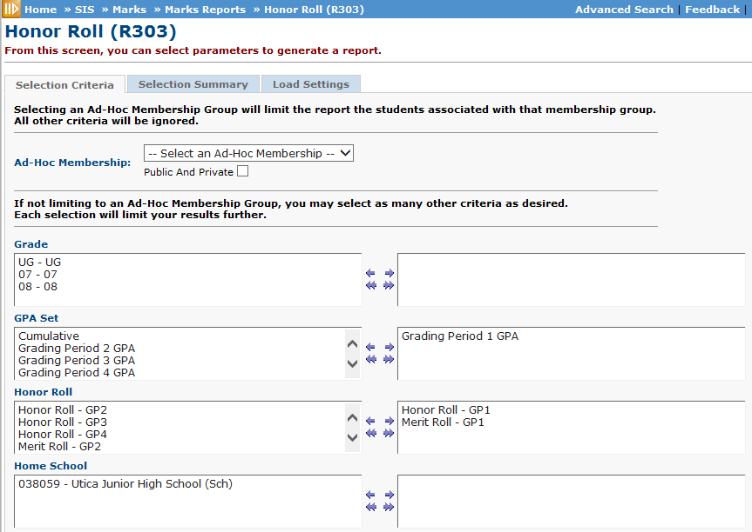
Section: Filter

- Ad Hoc Membership: Select an Ad-Hoc Membership from the drop-down menu if you wish to only include students associated with certain membership for this run of the report. To see all AD-Hoc groups check the Public and Private Checkbox. If this option is used all other filter options will be ignored.
- Grade: Choose one or more Grades you wish to include in the report. If you want all Grades, just leave them all to the left.
- GPA Set: Choose the GPA Set you just refreshed/calculated. This field is required, at least one GPA Set must be chosen.
- Honor Roll: If no Honor Rolls are selected, the report will use all Honor Rolls in creation of the report, or you can move the ones you want to the right. If there are no Honor Rolls to select from, they have not yet been created; go to Appendix A at the end of this document.
- Home School: Only used by a JVS. If you are not a JVS do not move any of them to the right or you will probably get fewer students than you want.
Section: Other Filters
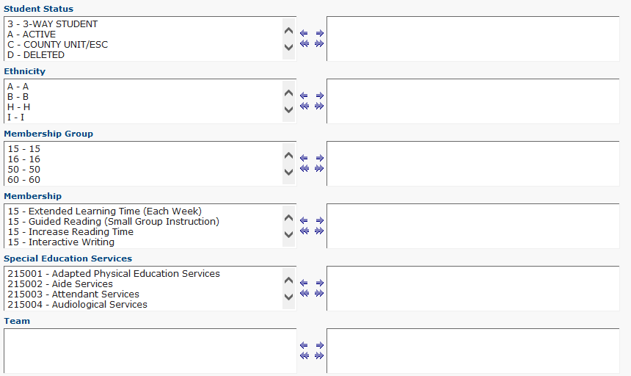

- Student Status: Move the student statuses you would like to limit to the right. If you want all statuses, just leave them all to the left.
- Ethnicity: If no ethnicity is selected, the report will select all ethnicities.
- Memberships Groups/Memberships: If you want to limit to only certain students based on certain EMIS Memberships.
- Special Education Services: If you only want students listed that have certain Special Education services, you can select those to the right.
- Team: If you have built teams you can list the report to just students in those teams by moving them to the right.
Section: Questions
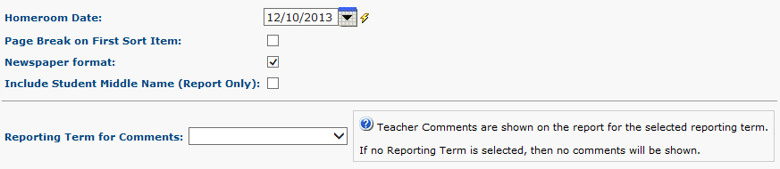

- Homeroom Date: Specify the date to use to retrieve students’ homeroom. Should fall within the current school year.
- Page Break on First Sort Item: If this checkbox is checked, each separate value for the first item chosen on Sorting Options will cause a new page to be printed in the report. For example, a JVS printing this report sorted first on IRN Attending would check this box to have a separate page(s) for each Home School.
- Newspaper Format: If this checkbox is checked, then no header or footer information will be shown on the report output, except the GPA Set and Honor Roll names. Also, only the student name and grade will be shown for each student, in the list of students who have achieved each Honor Roll.
- Include Student Middle Name (Report Only): If this checkbox is checked, then the student’s middle name will display on the report.
- Reporting Term for Comments: If report term is chosen, then the course code, course name, course section, and teacher comment are shown for each comment that the student has received in the selected reporting term, if the selected reporting term is associated with the GPA for which the student has an Honor Roll.
Section: Processing Options
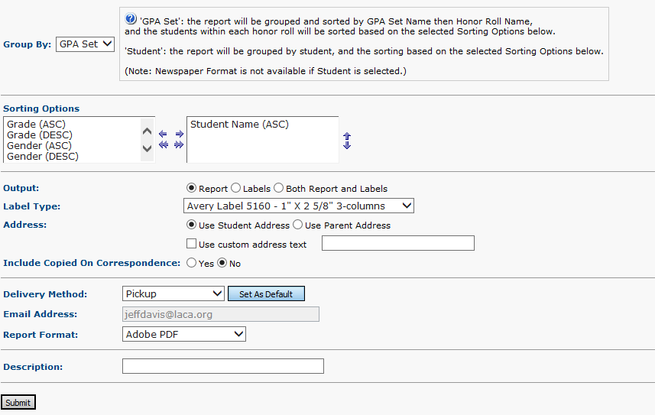

- Group By: You can choose to group and sort by GPA Set or Student. If GPA set is chosen, the data will be grouped by GPA Set Name then Honor Roll Name. The students within each honor roll will be sorted based on the selected sorting options. If student is chosen, the data will be grouped by student, and then sorted based on the selected sorting options.
- Sorting Options: Choose one or more sorting options for your report. ASC is ascending and DESC is descending.
- Output: Select Report, Labels, or Both Report and Labels. If you select both the two reports will be created separately. If labels are chosen, use the following Adobe page settings when printing the labels to ensure that the labels print correctly on the page:
  - For Adobe 9: Page Scaling = None, Auto Rotate and Center unchecked
  - For Adobe 10: Size Options = Actual Size, Orientation Portrait

If you are using Firefox, you must change a setting before printing labels. In Firefox, go to Tools then Options. On the Application window under Content type, locate Portable Document Format (PDF). In the Action column of that row, change the selection from Preview in Firefox to Adobe option (such as Use Adobe Acrobat).

- Label Type: If printing labels choose the appropriate preformatted labels you are using. Labels for this report have a default sort by Grade Level, then alphabetically by Name. If a different sort is selected for this report, labels will sort in the same order that the report is sorted.
- Address: You have the option to choose the student address on the Student Profile or the Primary Contact Address from the Contacts Page. You can add optional text to the top of the label by checking the use custom address text checkbox. Then place type your text in the field, e.g. “To the Parents of:”.
- Include Copied on Correspondence: If checked, those contacts that have “Copied on Correspondence” checked on their contact record will be listed on this report.
Step 4: Click Submit. Congratulations! You successfully submitted your R302 to the MGMT Screen.

Section: Appendix A – Verify You Have Honor Rolls Setup
If you are running the Honor Roll report and you are getting no students on the report, you may want to verify you have an Honor Roll created. You will know right away if there is one created, because the Honor Roll combo box shown on Page 2 will be empty if none are created.
A school may define multiple Honor Rolls and each one can be defined with different criteria. We recommend you contact LACA and we will help you define your Honor/Merit Rolls, but we will briefly explain it below.
Go to: Home » Management » School Administration » Marks Administration Menu » Honor Rolls
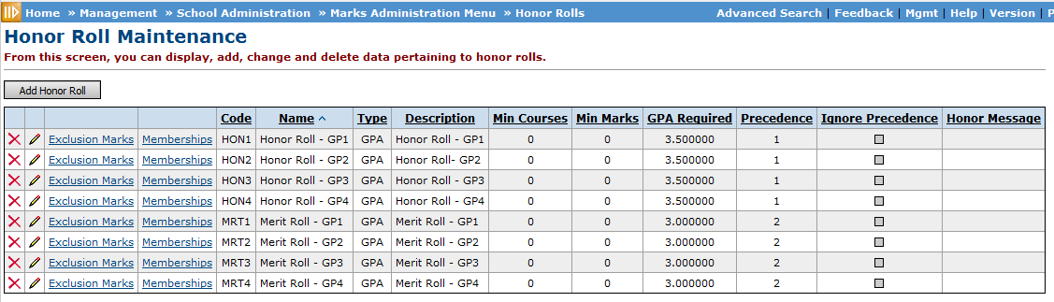

- The screen shot above is an example of building that created an Honor and Merit Role. Notice you have to build one for each GPA Set. Also, notice that the Ignore Precedence is unchecked which means if a student has a GPA greater than or equal to 3.5, they will only appear on the Honor Roll and not on the Merit Roll too.
Section: Adding New Rule
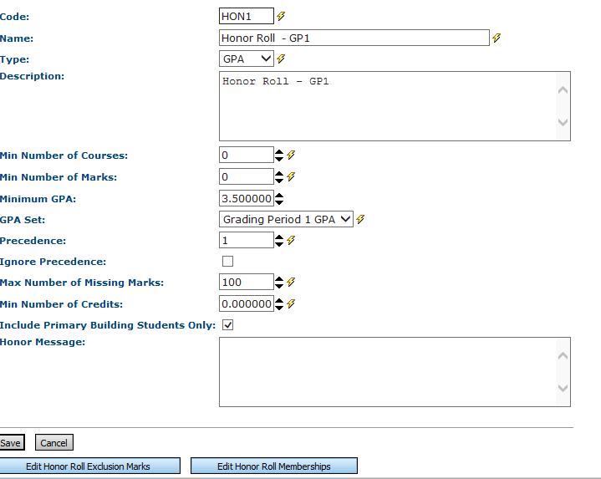

- Code: (Required) Enter up to 4 characters alphanumeric Honor Roll Code.
- Name: (Required) Enter Name of Honor Roll (up to 30 characters).
- Type: Valid responses are Point based, GPA Based and Mark based.
- Description: Enter the description of the Honor Roll (up to 200 characters).
- Min Number of Courses: (Required) Minimum number of courses that a student must have taken for the reporting period to qualify for this Honor Roll. Valid range of 0-20 may be used, with zero (0) indicating that no minimum is required.
- Min Number of Marks: (Required) Minimum number of marks that a student must have taken for the reporting period to qualify for this Honor Roll. Valid range of 0-50 may be used, with zero (0) indicating that no minimum is required.
- Minimum GPA: GPA required to qualify for this Honor Roll, with decimal values from 0-100 being used with a precision of two decimal places.
- GPA Set: (Required) Determines the GPA set to be used to determine Student GPA.
- Precedence: (Required) The precedence of the Honor Roll with Honor Rolls of the same type. The student may qualify for more than one Honor Roll, and precedence determines which Honor Roll the student receives. The Honor Roll with the lowest precedence value will be selected for a given student.
- Ignore Precedence: (Required) Flag indicating that the precedence rule will be ignored for this Honor Roll.
- Max Number of Missing Marks: (Required) The maximum number of missing marks allowed by marking pattern rules a student may have for the reporting period to qualify for this Honor Roll. Valid options are 1-100.
- Min Number of Credits: (Required) The minimum number of points the student must have attempted for the reporting period to qualify for the Honor Roll. Valid ranges of 0-100 may be used, allowing for decimal points in increments of 0.1. A zero (0) indicates that no minim is required.
- Include Primary Building Students Only: Functionality of this checkbox is not ready yet, but it needs to be checked.
- Honor Message: Texts message that will be printed on the report card if this option has been added to your report card.
- Edit Honor Rule Exclusion Marks: This button allows you to define specific marks that may include/exclude a student from and Honor Roll.
- Edit Honor Roll Memberships: This button allows you to define a student being excluded or included in a specific Honor Roll by virtue of belonging to a particular Membership Group.

